The Origin of Life
or
Call Me Chaim

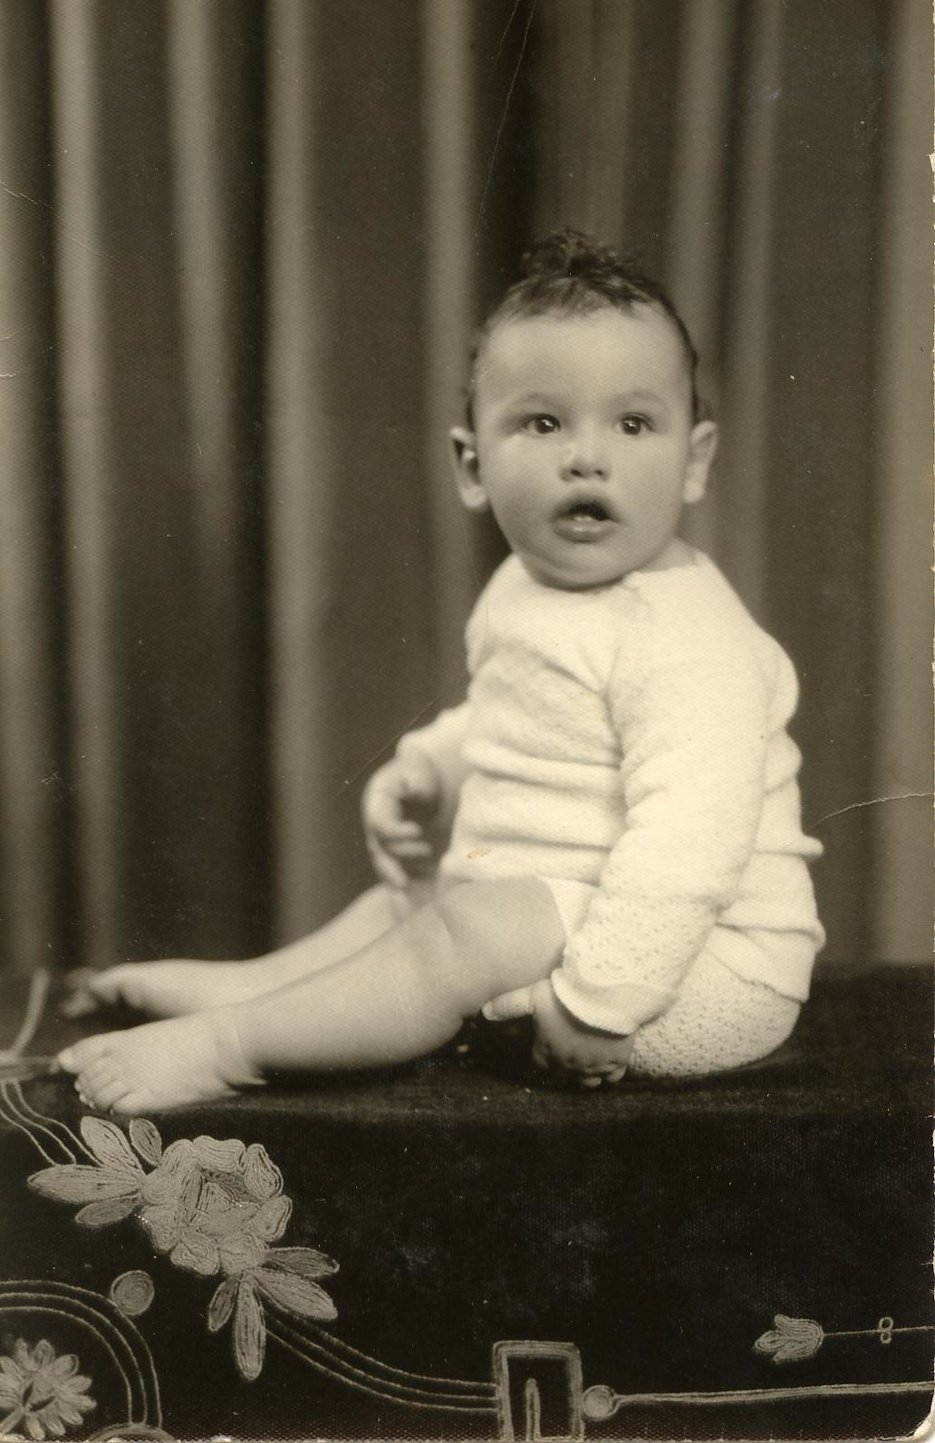

Fig 1

Let me introduce the reader to the author as a young man. When I was one year old (photograph), I was haunted by two metaphysical problems – Who am I and where did I come from? This then is my story in attempting to answer these two Question

For the purposes of this book, I am by profession a Biochemist who got his B.Sc in Biochemistry at McGill University (1957) and his PhD in Biochemistry from Columbia (1964). I later worked in the fields of Molecular Biology, Cell Biology, Embryology, and Neurobiology but my expertise is in the Origin of Life.
Where did you come from you the reader may ask? This is the scientific and philosophic road which I will travel with you the reader starting with my Origin at birth and ending with the Origin of Life.
I was born on June 5, 1936 to Hadassah Hartman (nee Wisenberg) and Cecil Nathan Hartman. They named me Chaim after my maternal Grandfather Hyman Wizenberg. “Chaim” in Hebrew is translated into “English” as Life. The problem then of my origin or where I came from originally is therefore the Origin of Life-. This is long tale but I will begin at my date of birth and work my way backwards in time from the birth of Chaim to the birth of Life itself. I hope to convince you, the reader, that the Origin of Life can be reconstructed from the life of any human being or for that matter any living organism. In a deep sense we are all “living memories” that stretch back in time to the Origin of Life.
The fetus and preformation

Let us then begin at my birth and go back into my mother’s womb and start our descent in time to conception. From Conception to Birth I spent approximately 38-40 weeks in my mother’s womb. The period from 9-40 weeks after Conception to birth is called the fetal period.
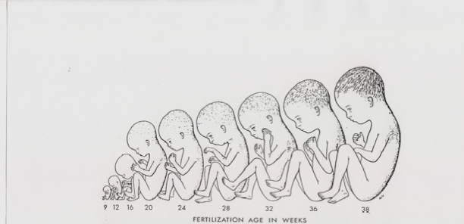
Fig 2
The Fetus and the Homunculus (38 weeks -9 weeks)
As can be seen in the figure at the head of this section (fig 1), the fetus diminishes in size. Approximately 75% of the time that I spent in my mother’s womb I was a fetus.
During that period I not only developed externally as seen in fig 1 but I was also developing internally. There was the development of the nervous system (Brain and Spinal Chord), the circulatory system (Heart, Arteries and Veins) the skeletal system (Skull, Vertebrate Column and Limbs) the muscular system (Skeletal Muscle, Cardiac Muscle and Smooth Muscle), the immunological system (Bone Marrow, Macrophages, B and T Cells etc), the respiratory system (Lungs), the digestive system (Stomach, Liver, Small Intestine and Large Intestine etc.) and the uro- genital system (Kidney, Bladder, Testicles and Ovaries etc)
Whether externally or internally I was shrinking into a smaller version of myself. One might then of course extrapolate back in time and predict that there was a little human or homunculus already there at conception. This would justify the idea that I was preformed.
But at week 8, I was now entering the embryonic period of my Development and the idea of Preformation will be replaced by Epigenesis. I was becoming simpler and simpler in form as well as size, The conclusion that is drawn is that I started out simple and grew more complex with time

The Embryo and Epigenesis
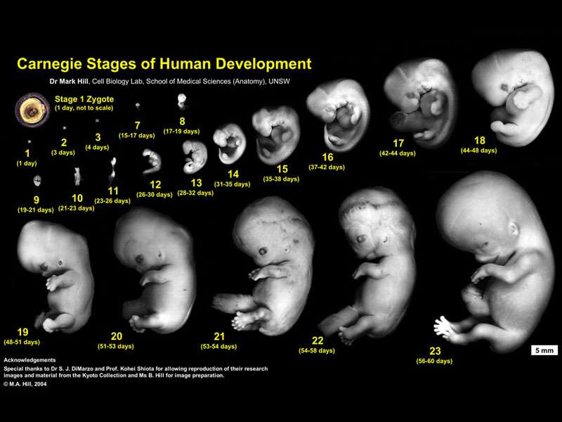
Fig 3
Before my fetal period in the womb I spent the first eight weeks as an embryo. In fig 2 there are the 23 stages of my embryogenesis as exemplified by the Carnegie collection of a human embryos. They start at day one after conception and end at eight weeks after conception.

The period from 4- 8 weeks was when the organs first matured and such as heart and brain are formed. This period in my embryology is called the Organogenetic period of my embryology (Carnegie stages 12-23). It is in this period from a three germ layer disc -(ectoderm, mesoderm and endoderm) and their interactions resulted in the formation of the nervous system (Brain and Spinal Chord), the circulatory system (Heart, Arteries and Veins) the skeletal system (Skull, Vertebrate Column and Limbs) the muscular system (Skeletal Muscle, Cardiac Muscle and Smooth Muscle), the immunological system (Bone Marrow, Macrophages, B and T Cells etc), the respiratory system (Lungs), the digestive system (Stomach, Liver, Small Intestine and Large Intestine etc.) and the uro- genital system (Kidney, Bladder, Testicles and Ovaries etc)
This period of my development led to the concept of epigenesis. What is eminently clear is that externally and internally I was no longer a mini -me and that I was not preformed.

It was at this stage in embryology that Aristotle asked the question
“ Either all the parts, as heart, lung, liver, eye, and all the rest, come into being together (preformation) or in succession (epigenesis), as is said in the verse ascribed to Orpheus, for there he says that an animal comes into being in the same way as the knitting (or weaving) of a net. As for simultaneous formation of the parts, our senses tell us plainly that this does not happen: some of the parts are clearly to be seen present in the embryo while others are not. “ (GA 734a 20 p 147).

“For its not the fact that when an animal is formed at that same moment a human being, a horse, or any particular sort of animal is formed, because the end or completion is formed last of all, and that which is peculiar to each thing is the end of its of formation.” (GA 736 b p166)

This set up a historically debated problem of Epigenesis and Preformation in my origin and what is more surprisingly in that of the origin of life itself.

Epigenesis, Evolution and the Onion Heuristic

Von Baer (1792-1876), who was the founder of comparative embryology, made an observation on vertebrate embryos that would bring my and your embryogenesis into the debates on Evolution.

The observation was as follows :
“The embryos of mammalia, of birds, lizards, and snakes, probably also of chelonian (turtles) are in their earliest states exceedingly like one another, both as a whole and in the mode of development of their parts; so much so, in fact, that we can often distinguish the embryos only by their size. In my possession are two little embryos in spirit, whose names I have omitted to attach, and at present I am quite unable to say to what class they belong. They may be lizards or small birds, or very young mammalia, so complete is the similarity in the mode of formation of the head and trunk in these animals. The extremities, however, are still absent in these embryos. But even if they had existed in the earliest stage of their development we should learn nothing, for the feet of lizards and mammals, the wings and feet of birds, no less than the hands and feet of man, all arise from the same fundamental form.” (Darwin OS p338)

If one observes the human embryo starting at eight weeks (stage 23) and earlier stages, it is clear that the embryo is getting smaller in size and looking less human. At four - five weeks (stage 16) the embryo is now looking like a chick embryo of four days after laying. Fig

Me at stage Carnegie Chick embryo at Day 3-4
stage 16 (week 4-5)
Fig 4
This is what Von Baer had observed but more broadly among vertebrate embryos.
Charles Darwin noted Von Baer’s observations on embryogenesis and interpreted this finding of von Baer’s as follows.
In two or more groups of animals, however much they may differ from each other in structure and habits in their adult condition, if they pass through closely similar embryonic stages, we may feel assured that they are all descended from one parent- form, and are therefore closely related.

Haeckel ( 1834 – 1919)
Haeckel, who was the most spirited expositor of Darwin in Germany, coined the phrase Ontogeny Recapitulates Phylogeny.

He put Von Baer’s Observation with others and drew figure 5 which renders the thought of von Baer on vertebrate development in graphic form.

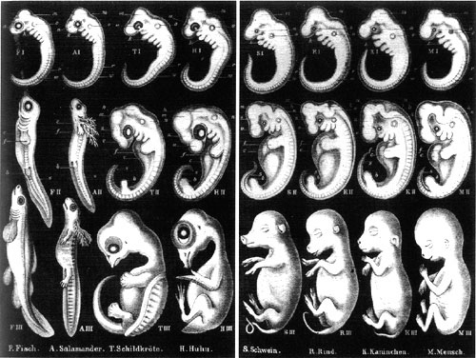
Fig 5

Haeckel then agreed with Darwin -
There is but one explanation of it –heredity from a common parent form. When we see that, at a certain stage, the embryos of man and the ape, the dog and the rabbit, the pig and the sheep, although recognizable, as higher vertebrates cannot be distinguished from each other, the fact can only be elucidated by assuming a common parentage. (Riddle of the Universe p 65).

Epigenesis of the vertebrate embryo now came to be used as an example for Darwin’s Evolutionary Theory of Descent with Modification from a common ancestor.

Haeckel went on to formulate his Law of Organic Evolution which can be simply formulated- Ontogeny (Embryology) recapitulates Phylogeny (Evolution).

This not a Law but a Heuristic, a rule of thumb
"the fundamental law of organic evolution," or “ the fundamental law of biogeny." This general law, to which we shall find ourselves constantly recurring, and on the recognition of which depends one's whole insight into the story of evolution, may be briefly expressed in the phrase: “The history of the fetus is a recapitulation of the history of the race"; or, in other words, “ Ontogeny is a recapitulation of phylogeny." It may be more fully stated as follows: The series of forms through which the individual organism passes during its development from the Ovum to the complete bodily structure is a brief, condensed repetition of the long series of forms which the animal ancestors of the said organism, or the ancestral forms of the species, have passed through from the earliest period of organic life down to the present day.
Haeckel gave an alphabetical analogy for this principle- A thru Z.
The chain of manifold animal forms which represent the ancestry of each higher organism, or even of man, according to the theory of descent, always form a connected whole. We may designate this uninterrupted series of forms with the letters of the alphabet: A, B, C, D, E, etc., to Z.

The best example of Ontogeny recapitulation of Phylogeny is the case of terminal addition. There is a nice diagram for terminal addition in Stephen Jay Gould’ s book –Ontogeny and Phylogeny.

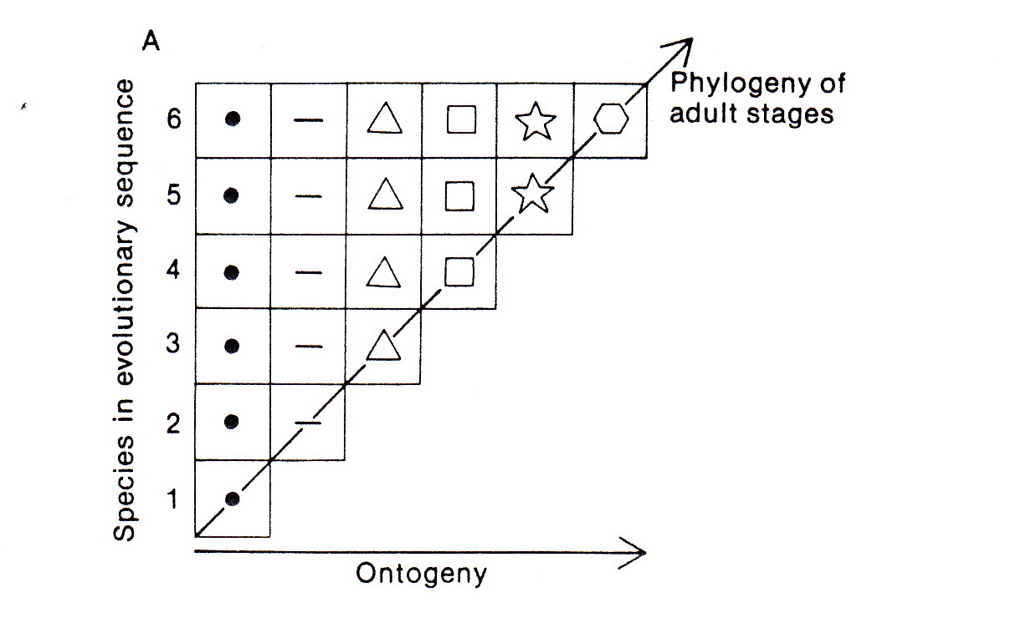
Fig 6
What is is shown in fig (6) is what is called the principle of terminal addition. The evolution of biological complexity is accomplished by adding on to an existing structure. I call it is the onion heuristic that will allow us to reconstruct the evolution of the genetic code and metabolism.

Embryonic Week 2-4
Let us return to our embryonic early period , we left off our embryo at week 4.
week 4
Fig 7

We will now going back to week 3.

Week 3
end of week 3
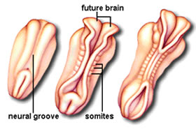
neural groove
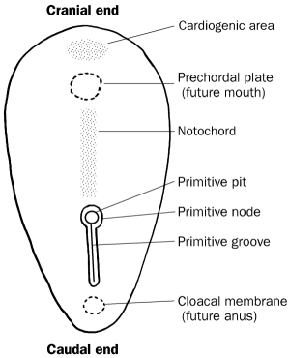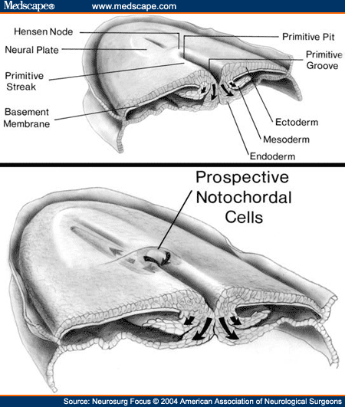
Gastrulation
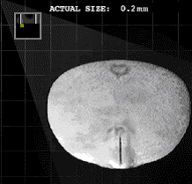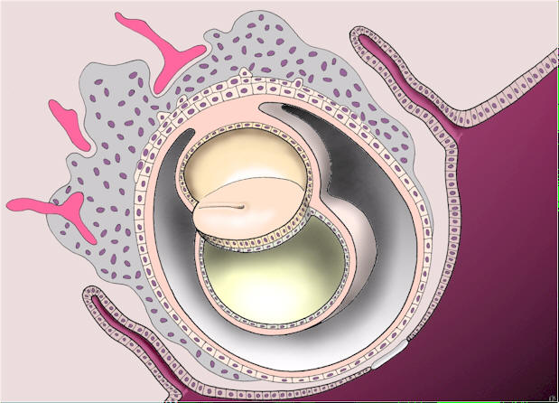
The two layer disc has begun to form the primitive streak.
In week 3, the formation of the primitive streak in the two layer disc is where gastrulation occurred and results in the formation of a three germ layer disc from a two layer disc. There are now ectoderm, mesoderm and endoderm.

The most dramatic events in week 3 are the formation of the primitive streak, the formation of the neural groove and the somites.
Week 2

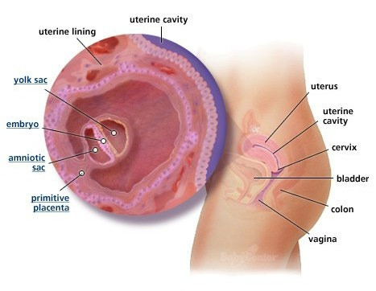
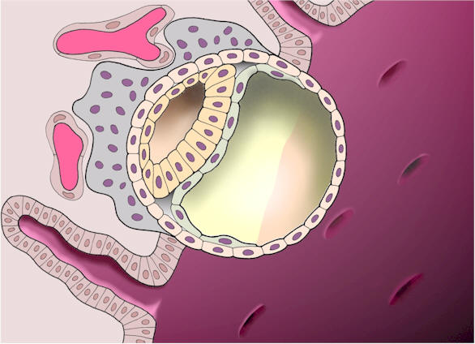

The blastocyst has embedded itself in the endometrium of the uterus and has formed a two layered disc.
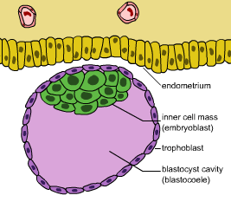
The Blastocyst about to embed itself into the endometrium of the uterus

The two main events of week 2 is the embedding of the blastocyst into the uterus and the formation of the layered disc from the inner cell mass. The size of the imbedded blastocyst is that of the period at the end of this sentence. The description of the embryo is now at the cellular stage.

Week 1

The formation of the Blastocyst from the fertilized egg

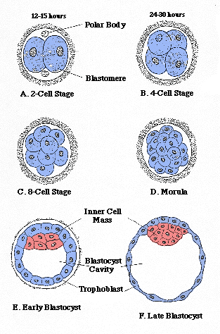

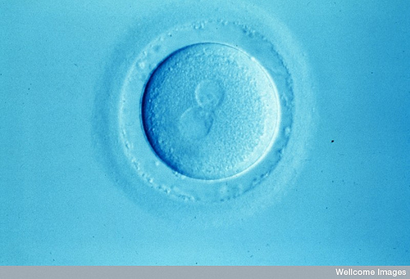

Fertilization.
There are two nuclei in the fertilized egg One came from the unfertilized Egg and the other came from my fathers sperm.

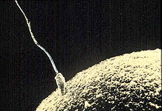

The sperm is working its way into the egg headfirst and will deposit the sperm nucleus into the egg - the two nuclei will meet and fuse. The fertilized egg will then divide into two cells and embryogenesis will begin – Morula (First week), Blastocyst (Second week), 2 layer disc, primitive streak and gastrulation , neural groove (Third week), organogenetic stage (4th -8th week), fetal period (9th-40th week ) and then birth. I have thus traced my origin to my father’s sperm and my mother’s unfertilized egg cell.

The get further back into my origin, I must trace back the Origin of the Sperm and the Egg,

